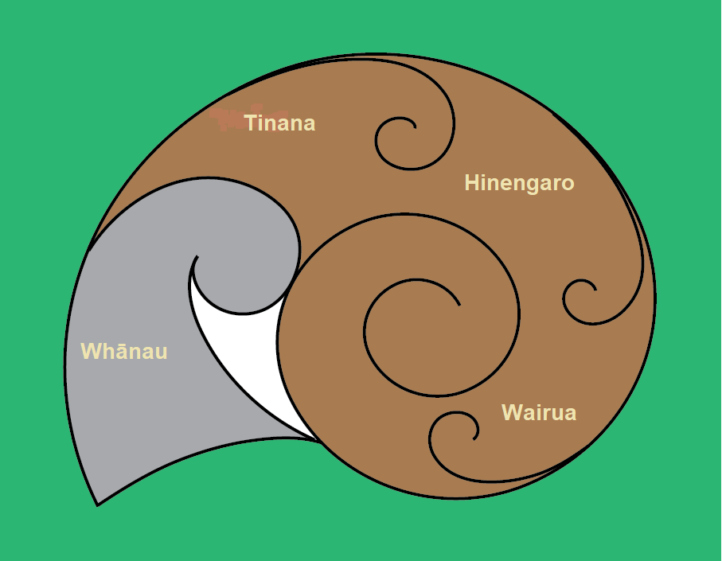This is a visual representation using Ngata (snails) as a metaphor for those who live with chronic pain.

Ngata (native snails) are used for medicinal purposes for Māori. Ngata represent a metaphor for those that live with chronic pain on a daily basis and their whanau. The four KORU in the Ngata represent Hinengaro (mental health), Wairua (connectedness, place, spirituality), Tinana (physical health) and Whānau (family, support). The Ngata is also a metaphor for whānau going within their shells when they are not feeling well.

Pain can affect all aspects of you as a person and your whānau:

* People may feel less physically well and active – Tinana
* People may feel less well mentally – Hinengaro
* People may feel less connected – Whānau
* Pain may affect who you are and what is important to you – Wairua

You and your whānau may have withdrawn into the shell waiting for pain to get better. If you and your whānau feel you are stuck inside the shell of pain and you are struggling to move on, this programme will help you look at things you can do to get out of the shell and get on track with what is important to you despite pain.