**Chronic Pain and Other Bad Habits**

Not all neurosignatures our brain lays down are necessarily helpful. Just like repetition strengthens helpful habits and patterns, it also strengthens unhelpful ones. If you have ever tried to stop smoking or eating sweets, or drinking alcohol, to mention just a few unhelpful habits, you will be aware of the enormous effort it took you not “just to do it”. A situation, smell or feeling may trigger you reaching for something and you often may not even realise that you had lit up or got something out of the pantry until later. The neurosignature has become an established pathway because every time neurons fire together, their connection gets stronger and their pathway easier to trigger.

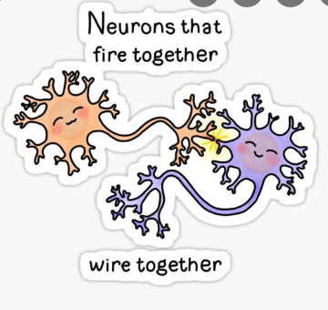

**Chronic Pain Neurosignatures**

While you have experienced pain for the last months or even years, the neurons involved in your experience of pain have become stronger and easier to trigger. Whatever the initial reason, by now it is more likely for you to experience pain due to the well-worn path of your pain neurosignature. You may have a wide range of triggers that increase your pain or may not be able to put your finger on any specific reliable triggers and this can often be explained by the fact that so many more parts or neurotags of your neurosignature can now set off this well-worn path.

This is in addition to whatever may trigger your pain in the body and is so powerful that it may not need physical triggers in the body at all.

**Neuroplasticity**

The good news is that our brain adapts all the time and we can create new pathways every day. Just like anyone that managed to quit smoking or any other bad habit can tell you, with determination, repetition and perseverance, new neurosignatures can become wider and easier for the brain to choose. Your brain won’t completely forget or dismantle a well-worn path, but if you create an alternative route it will more and more easily choose this new path. It is likely to run the old pain neurosignature every now and again, so being prepared for pain flares even when you pain improves can be helpful.