CARE WORKER FOOT & HAND CARE GUIDE

Residents with foot or hand deformities are at higher risk of developing pressure injuries especially if they experience loss of sensation or numbness. People with diabetes are at higher risk. YOU can make a difference by following this guide.
If you have any questions, please ask your supervising nurse.
SKIN INSPECTION & CARE | 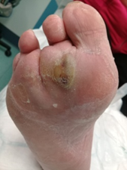 | - Wash, dry, and check feet daily, especially between the toes. Report red skin, cracks, blisters, or areas of hard skin (callus) to the nurse.  - Avoid cream between toes to reduce fungal infections.  - Dry heels: apply Urea 10% cream at least daily, as prescribed by the Doctor or Nurse Practitioner (NP).  - If toes are swollen, weave a single dry gauze between the toes to absorb moisture and change daily.
FOOT DEFORMITY  & PRESSURE RISK | 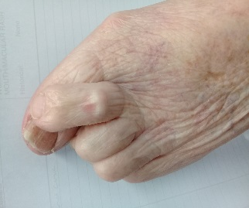 | - Any abnormal foot and toe shape can increase the risk of pressure injuries especially when footwear is poorly fitting or have no back support for walking.  - If toes are crossing-over, place gauze between toes to separate and report to the nurse to consider a Podiatrist review for appropriate toe separators or shoes.  - Wear socks with shoes to help reduce friction and blisters, socks should be seam free or worn inside out to prevent skin marking. If red marks or blisters occur footwear may be too tight so remove and report.  - Shoes should have a wide toe box with no rough seams or areas that rub. Check inside footwear for any foreign objects before applying.  - New shoes should be worn for short periods (20-60 minutes) and then check the feet for any red skin marking. They should not be used if red skin marking is occurring.
NAIL CARE | 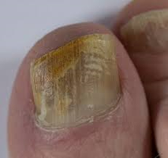 | - Do not cut thickened toenails due to the risk of causing injury.  - Routine Podiatry input is important to trim thickened nails and manage callus.  - Thickened and discoloured toenails may indicate a fungal infection. Report this to the nurse.
HAND HYGIENE  & CARE | 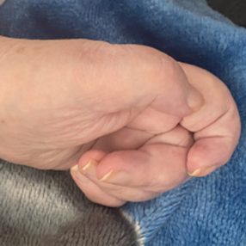 | - Encourage residents to wash their hands before eating and after the toilet.  - Assist residents with no or poor hand function with hand hygiene. Take care to clean and dry between the fingers.  - Contractures cause one or more fingers to bend toward the palm of the hand increasing the risk of moisture and pressure injuries on the palm. Do not apply cream between the fingers. Keep nails short and filed. Report broken or red skin. Folded foam or cloths inside the palm to manage moisture and provide protection should be assessed by the nurse.
Aged Residential Care: Pressure Injury Project Working Group Care Worker Training Module. Published November 2025. HE4341.

