Standard Greeting
We are pleased to report that your recent bowel (poo) test was negative. This means it is unlikely your symptoms are caused by bowel cancer.
This test is not 100% accurate for detecting bowel cancer, and in addition there could be other causes for your symptoms which may need treatment.
Book in with your GP for a check-up if:
- your symptoms become worse at any time
- your symptoms continue for more than 6 weeks.

Standard finish

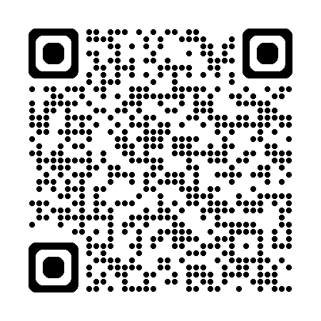
Read This Letter Your Way
Need larger text or a screen reader-friendly version? Scan the QR code with your phone to view these options.
If you are Deaf, hard of hearing, deafblind, or have difficulty with speech, you can contact us through New Zealand Relay at nzrelay.co.nz
Kia pānuitia tēnei reta i te reo Māori, whakaritea tō kāmera i tō waea, ā, tohua ki te tohu QR kei runga ki te matau o te whārangi. Ka puta mai tētahi hononga ki te kawe i a koe ki te paetukutuku.
Kia paanuitia teenei reta i te reo Maaori, whakaritea too kaamera i too waea, aa, tohua ki te tohu QR kei runga ki te matau o te whaarangi. Ka puta mai teetahi hononga ki te kawe i a koe ki te paetukutuku.
A fia faitau i le Gagana Samoa, tatala le QR code i le meapueata o lau telefoni. E maua ai le itulau faaopoopo e tatala sa‘o ai le upegatafailagi.
Ke lau ‘a e tohi ko ‘ení ‘i he lea faka-Tongá, fakaava ‘a e me‘afaitā ‘i ho‘o telefoní pea fakahangatonu ki he kouti QR ‘i ‘olunga ‘i he tafa‘aki to‘omata‘u ‘o e peesí. ‘E ‘asi mai ai ha fakafehokotaki‘anga (link) ke tataki koe ki ha uepisaiti.
No te tatau‘anga i teia reta i roto i te reo Maori Kūki ‘Airani, ‘akatu‘era‘ia te nene‘i i runga i ta‘au terepōni, ma te to‘u i te reira ki runga i te QR code tei te pae i runga i te tua katau o te kapi. Ka ata mai teta‘i ‘ātui‘anga (link) i te arataki iākoe ki teta‘i kupenga uira.
Ke maeke ke totou e tohi nei he vagahau Niue, veveu e pokiata he haau a telefoni utafano mo e tuhi aki e QR code he faahi matau ki luga he laupepa. To hake mai e taha laini ko e matutakiaga ke taatu a koe ke he taha poko kupega hila.
Kafai e manakomia ke faitau tēnei tuhi i te Gagana Tokelau, tatala te pukeata o tau telefoni ma fakatu ki te QR code i luga o te itū taumatau o te pahina. E iei he link e hula mai e fakahino atu ai te tuātuhi i te vāteatea.
Mo wilika na ivola qo ena vosa vakaViti, mo dolava na nomu itaba ni talevoni qai tabaka na QR code ena yasa imatau e cake ena ivola qori. E dua na isema ena kauti iko ena website.
La hat put te‘is ‘e fäeag Rotuḁm ta, a‘es‘ao‘åk tē sikiḁg mḁl heta ‘e ‘ou telefon ta ma ag‘åk se QR code heta ‘e rer ne peap ta ‘e hanhap ‘atmḁi ta. Ta link het la no‘om ne la hoa‘ ‘äe se ta website het.
Ke faitau faka Tuvalu a te tusi tenei, tala te mea peiata o tau telefoni tauave kae fakasaga ki te Fakatokaga i Fakamaoniga o Fakamatalaga (QR code) i te feitu fakaatamai tafa ki luga o te laupepa. E isi se sokoga ka sae mai o fakasoko koe ki te laupepa iti.
इस पत्र को हिंदी भाषा में पढ़ने के लिए, अपने फोन का कैमरा खोलें और इसे पृष्ठ के सबसे ऊपर दाईं ओर क्यूआर कोड पर इंगित करें। आपको एक वेबसाइट पर ले जाने के लिए एक लिंक प्रकट होगा।
如要用中文阅读这封信，请打开手机的摄像头并将其对准页面右上角的二维码。然后将出现一个链接，引导您进入一个网站。

