NHI: XXXXXXX
Date: (day/month/year)

First Name Last Name
Address 1
Address 2
Town/City Postcode

Tēnā koe/Dear First name Last name,

Repeat your FIT test
Thank you for sending your FIT test to us. Unfortunately, we could not test your sample for the following reason:

• << FIT Test Result. Result Error Code >>

Here is a new FIT kit. It is important you do this test as soon as you can in the next few days. Your test result will help us decide how we will manage your symptoms.

What you need to do next
- Follow the instructions inside the enclosed test kit.
- Write the date you did the test on the request form. We cannot process undated tests. If you do not date your test, you will need to do another one.
- Post the sample in the pre-paid envelope on the same day or the day after. This minimises the risk of the sample being spoilt.

Thank you for doing the FIT test. We will be in contact with you within 4 weeks after we get the result.

If you have any questions, contact us using the phone number or email listed below. One of our team members will be happy to help you.

Ngā mihi/Yours sincerely,

Endoscopy Unit
XXX District
Phone Number extension
Email
Health New Zealand | Te Whatu Ora

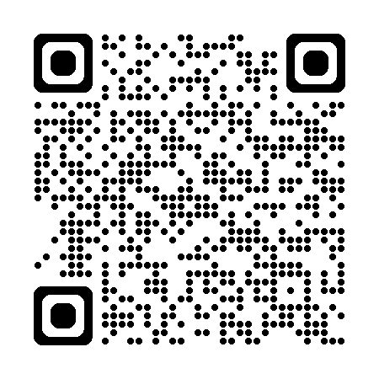
Read This Letter Your Way
Need larger text or a screen reader-friendly version? Scan the QR code with your phone to view these options.
If you are Deaf, hard of hearing, deafblind, or have difficulty with speech, you can contact us through New Zealand Relay at nzrelay.co.nz
Kia pānuitia tēnei reta i te reo Māori, whakaritea tō kāmera i tō waea, ā, tohua ki te tohu QR kei runga ki te matau o te whārangi. Ka puta mai tētahi hononga ki te kawe i a koe ki te paetukutuku.
Kia paanuitia teenei reta i te reo Maaori, whakaritea too kaamera i too waea, aa, tohua ki te tohu QR kei runga ki te matau o te whaarangi. Ka puta mai teetahi hononga ki te kawe i a koe ki te paetukutuku.
A fia faitau i le Gagana Samoa, tatala le QR code i le meapueata o lau telefoni. E maua ai le itulau faaopoopo e tatala sa‘o ai le upegatafailagi.
Ke lau ‘a e tohi ko ‘ení ‘i he lea faka-Tongá, fakaava ‘a e me‘afaitā ‘i ho‘o telefoní pea fakahangatonu ki he kouti QR ‘i ‘olunga ‘i he tafa‘aki to‘omata‘u ‘o e peesí. ‘E ‘asi mai ai ha fakafehokotaki‘anga (link) ke tataki koe ki ha uepisaiti.
No te tatau‘anga i teia reta i roto i te reo Maori Kūki ‘Airani, ‘akatu‘era‘ia te nene‘i i runga i ta‘au terepōni, ma te to‘u i te reira ki runga i te QR code tei te pae i runga i te tua katau o te kapi. Ka ata mai teta‘i ‘ātui‘anga (link) i te arataki iākoe ki teta‘i kupenga uira.
Ke maeke ke totou e tohi nei he vagahau Niue, veveu e pokiata he haau a telefoni utafano mo e tuhi aki e QR code he faahi matau ki luga he laupepa. To hake mai e taha laini ko e matutakiaga ke taatu a koe ke he taha poko kupega hila.
Kafai e manakomia ke faitau tēnei tuhi i te Gagana Tokelau, tatala te pukeata o tau telefoni ma fakatu ki te QR code i luga o te itū taumatau o te pahina. E iei he link e hula mai e fakahino atu ai te tuātuhi i te vāteatea.
Mo wilika na ivola qo ena vosa vakaViti, mo dolava na nomu itaba ni talevoni qai tabaka na QR code ena yasa imatau e cake ena ivola qori. E dua na isema ena kauti iko ena website.

La hat put te‘is ‘e fäeag Rotuḁm ta, a‘es‘ao‘åk tē sikiḁg mḁl heta ‘e ‘ou telefon ta ma ag‘åk se QR code heta ‘e rer ne peap ta ‘e hanhap ‘atmḁi ta. Ta link het la no‘om ne la hoa‘ ‘äe se ta website het.
Ke faitau faka Tuvalu a te tusi tenei, tala te mea peiata o tau telefoni tauave kae fakasaga ki te Fakatokaga i Fakamaoniga o Fakamatalaga (QR code) i te feitu fakaatamai tafa ki luga o te laupepa. E isi se sokoga ka sae mai o fakasoko koe ki te laupepa iti.
इस पत्र को हिंदी भाषा में पढ़ने के लिए, अपने फोन का कैमरा खोलें और इसे पृष्ठ के सबसे ऊपर दाईं ओर क्यूआर कोड पर इंगित करें। आपको एक वेबसाइट पर ले जाने के लिए एक लिंक प्रकट होगा।
如要用中文阅读这封信，请打开手机的摄像头并将其对准页面右上角的二维码。然后将出现一个链接，引导您进入一个网站。

