**Pain Management Programme: Exercises**

**Strength**

*Exercises 1 and 2 assist in activating muscles important in posture. Once you are confident with them, practice the following exercises with your stomach and shoulder muscles activated.*

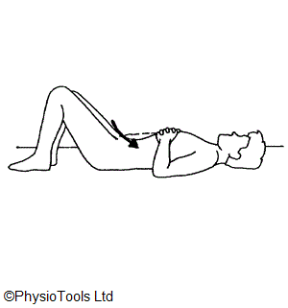

1. Transverse Abdominis:

Lie on your back with your knees bent.

Draw your belly button towards the spine. Aim to hold while breathing in and out.

Release the tension and complete a full breathing cycle before repeating this exercise

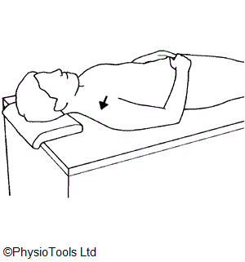

1. Lower Trapezius:

Lie on your back. Gently bring your shoulder blades inwards and downwards towards the centre of your spine. This should be a small movement only.

Aim to hold while breathing in and out.

Release the tension and complete a breathing cycle before repeating this exercise

*Complete the following exercises slowly and in a controlled manner. When the movement is controlled, your muscles work harder and likely with a better technique.*

1. Hip abduction:

Lie on your back with your knees bent. Contract your abdominal muscles (as in exercise 1), and back muscles (as in exercise 2) and gently move your knee out to one side, then bring it back in. Release the tension and complete a breathing cycle before repeating the exercise and moving the other knee.

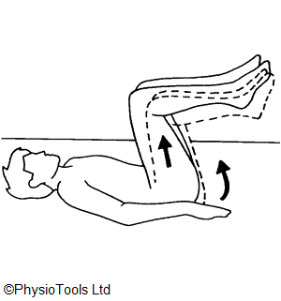

1. Foot lifts:

Lie on your back with your knees bent and contract your abdominals (as in exercise 1). Prepare to lift one foot off the ground. As you become more confident, you can lift your foot higher.

To make this exercise more difficult, you can lie on your back with your hips and knees at 90 degrees (your feet will be off the floor). Lower one foot so it touches the ground then back up. Repeat with the opposite leg.

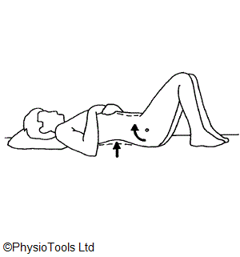

1. Bridges:

Lie on your back with your knees bent.

Lift your tailbone off the floor and slowly return.

As you progress, lift tailbone, hips and lower backlift your hips off the floor.

1. Clams:

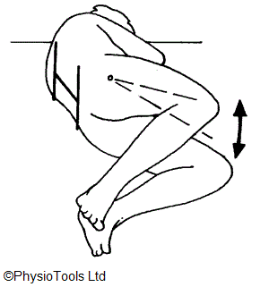

Lie on your side with your knees bent. Keeping your foot together, lift the top knee, then place it back down. As you become more confident, lift your knee higher.

Repeat 15 times with each leg.

To increase the difficulty, you can straighten your top leg, and lift your foot into the air (see right).

1. 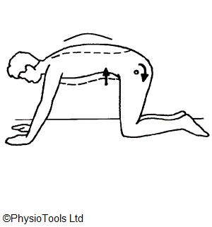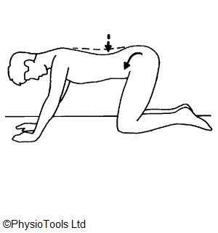Cat-camel:

On your hands and knees, (shoulder-width apart), round your back towards the ceiling.

Hold for 5-8 seconds.

Bend in the opposite direction to create a dip in your lower back (see diagrams).

Repeat 7-10 times.

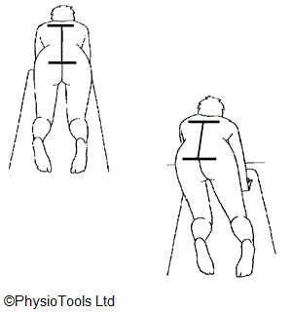

1. Weight distribution:

On your hands and knees, practice shifting your weight forwards and backwards, and side to side. Keep your abdominal muscles engaged (as in exercise 1).

1. Superman:

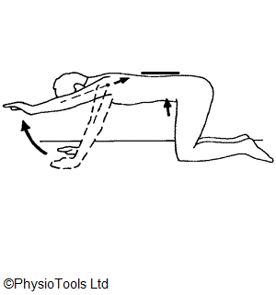

While on your hands and knees, engage your abdominal muscles. Gently lift one arm in front of you, keeping the rest of your body still. Return to the original position.

Repeat 10 times with each arm. When this becomes too easy, lift one leg at a time.

To make this exercise more difficult, lift one arm and the opposite leg at the same time, keeping your back still.

1. 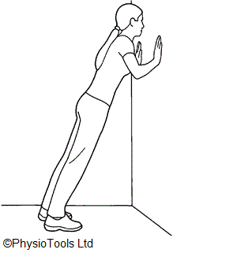Wall-push up:

Place your hands on a wall in front of you. Contract your shoulder muscles as in exercise 2. Lean forwards into a push-up against the wall.

Repeat 8-10 times.

To make this exercise more difficult, move your feet further out from the wall.