**🧠 Memory of Pain**

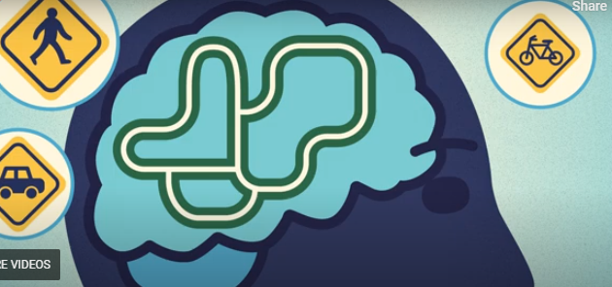

**🌟 Key Learnings**

* **Memory is central to learning**, helping us store and recall information for future use.
* Repetition strengthens neural pathways—**“Neurons that fire together, wire together.”**
* The brain builds **automatic pathways** based on repeated experiences.
* While experiencing pain, **places, activities, and emotions** experienced at the timebecome associations that may trigger pain in the future.
* We often **anticipate pain** based on past experiences.
* The brain’s **bias toward remembering negative events** (like pain) can shape behaviour and avoidance patterns.
* Fortunately, **neuroplasticity** means we can reshape these pathways and create new, more helpful ones.

**🛠 Skills to Practise**

* **Recall neutral or positive experiences**—try starting a gratitude journal.
* When doing something that tends to increase pain, consider:
  + **Breathing techniques** before, during, and after the activity
  + **Modifying sensory input** you can control:
    - Sound/music
    - Light
    - Smells
    - Touch (e.g., tap, rub, or use TENS)
  + **Identifying and adjusting thinking patterns** that arise in these situations

## ❓ Quiz: Memory of Pain

**Question 1:** What does the phrase “Neurons that fire together, wire together” mean?

* 1. Pain neurons are permanently connected
  2. Repeated experiences strengthen neural pathways
  3. Pain always leads to emotional trauma
  4. Neural pathways cannot be changed once formed

**Explanation:** Repetition strengthens connections between neurons, making responses like pain more automatic over time. **Answer:** B

**Question 2:** Why can pain-related memories make future pain more likely?

* 1. Because the brain ignores past experiences
  2. Because pain memories are stored in the spinal cord
  3. Because anything we experience repeatedly becomes easier to recall
  4. Because pain memories are erased quickly

**Explanation:** Our brain lays down memories of our pain experiences and learns associations of pain and other factors, which can trigger pain responses in similar future situations. **Answer:** C

**Question 3:** What is a helpful skill for reshaping pain-related memories?

* 1. Avoiding all activities that previously caused pain
  2. Repeating negative thoughts to desensitise yourself
  3. Ignoring pain and pushing through it
  4. Actively remembering neutral or positive experiences

**Explanation:** Focusing on positive and neutral experiences helps create new, more helpful neural pathways. **Answer:** D

**Question 4:** What is a neurotag?

* 1. A component of a neurosignature linked to specific experiences
  2. A type of pain medication
  3. A memory stored in the spinal cord
  4. A muscle group affected by pain

**Explanation:** Neurotags make up neurosignatures, a complex connection of nerves in the brain and spinal cord that enables automatic actions and reactions. **Answer:** A