**Sensory Nervous System**

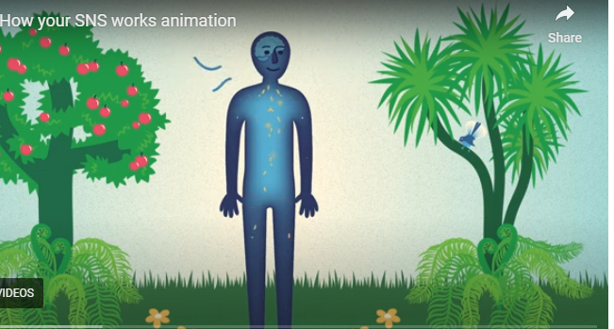

**🌟 Key Learnings**

The sensory nervous system creates all sensory experiences, including what we see, taste, hear feel and pain.

Sensations cause action: we look for a place of shelter or clothing when cold, something to eat when hungry and a place to sleep when tired. This is its way to keep us alive and to thrive.

Whether something tastes ‘yum’ or ‘yuck’ is depending on the sensory nervous system appraising the available information about this food being ‘good’ or ‘unsafe’. There are no yum and yuck taste buds.

Pain is a sensations created when the available information indicates that a body part might be at risk. There are no pain receptors in the body.

The spinal cord filters and moderates sensory inputs, determining what is important or not important for our immediate response.

The sensory nervous system adapts with each experience. It can become more sensitised or less responsive over time

The sensory nervous system makes wrong decisions and can be the cause of diseases, like chronic pain

**🛠 Skills to Practise**

Take note of the decision making of your sensory nervous system – what feels nice/unpleasant and why might that be?

Reflect on sensory experiences that have changed over time and what factors may have led to this change

Incorporating “Hurt does not mean Harm” into your thought processes around pain

Consider the language you use to reflect the disease process of the sensory pain system rather than body being ‘broken’

## **❓ Quiz: Sensory Nervous system**

**1. What is one key function of the spinal cord in the sensory nervous system?**

1. It creates emotional responses to pain
2. It filters and prioritizes sensory input for immediate action
3. It stores long-term sensory memories
4. It controls voluntary muscle movement

**Explanation:** The spinal cord filters and moderates sensory inputs, helping determine what requires immediate attention. **Correct answer:** B

**2. Which statement about pain is most accurate?**

1. Pain is purely a physical sensation
2. Pain is only caused by injury
3. Pain is both a sensory and emotional experience
4. Pain always means the body is damaged

**Explanation:** Pain involves both sensory input and emotional interpretation, helping protect us from harm. **Correct answer:** C

**3. What does “Hurt does not mean harm” encourage us to do?**

1. Ignore all pain signals
2. Assume pain is always dangerous
3. Reframe pain as a protective response, not necessarily damage
4. Seek immediate medical attention for any discomfort

**Explanation:** This phrase helps shift thinking from fear-based reactions to understanding pain as a signal, not proof of injury. **Correct answer:** C

**4. Which of the following is NOT true about the sensory nervous system?**

1. It can change over time through experience
2. It helps us interpret both internal and external stimuli
3. It evaluates sensory input for safety and meaning
4. It always makes accurate decisions

**Explanation:** The sensory nervous system is not always accurate—it errs on the side of caution to protect us. **Correct answer:** D