**😣 Stress Response**

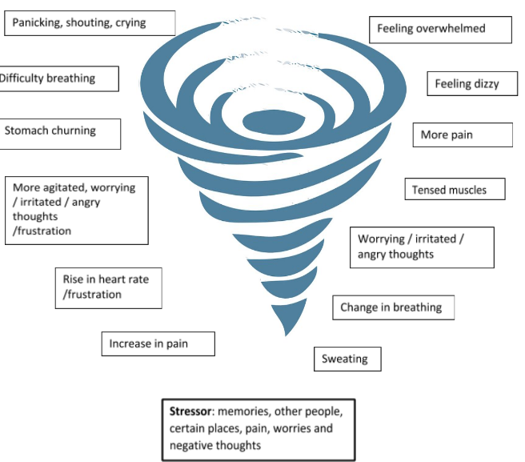

**🌟 Key Learnings**

* **Pain triggers** the **stress response** a state of heightened alertness.
* The **stress response is automatic**, part of our body’s built-in protection system—think **fight, flight, or freeze**.
* While stress prepares us for action, **chronic activation** can drain energy and make daily life harder.
* You can **influence your stress response** through conscious practices like **slowing your breath** and **relaxing muscles**.
* Everyone experiences stress differently—**recognising your personal triggers** and soothing techniques is key.
* **Environmental factors** play a big role in stress—being aware of your surroundings helps you adapt and manage better.

**🛠 Skills to Practise**

* **Notice early signs** of your body’s stress response.
* **Focus on your breath** when pain or stress increases.
* **Try** **breathing out longer** while softening a muscle group—repeat several times a day.
* **Listen to relaxation scripts** to help calm your system.

## ❓ Quiz: Stress Response

**Question 1:** What is the main purpose of the stress response in the body?

* 1. To help us sleep better
  2. To prepare us for action in response to perceived threats
  3. To reduce pain instantly
  4. To improve digestion

**Explanation:** The stress response activates protective changes like increased alertness and muscle tension to help us respond to danger. **Answer:** B

**Question 2:** Which of the following is NOT a helpful skill for managing the stress response?

1. Noticing early signs of stress in your body
2. Breathing out slowly while relaxing a muscle group
3. Ignoring stress and pushing through pain
4. Listening to relaxation scripts

**Explanation:** Ignoring stress can worsen symptoms. Calming techniques help regulate the stress response. **Answer:** C

**Question 3:** Why can the stress response become unhelpful in chronic pain?

1. It improves digestion
2. It stops working altogether
3. It only responds to emotional threats
4. It becomes constantly activated, leading to fatigue and increased pain

**Explanation:** Chronic activation of the stress response drains energy and can amplify pain and emotional distress. **Answer:** D

**Question 4:** Which of the following statements is TRUE about the “better safe than sorry” principle?

1. The brain triggers protective responses even if the threat isn’t real
2. The brain sees false alarms as failures
3. The brain prefers to underreact to threats
4. The brain ignores past experiences when assessing danger

**Explanation: survival is key and having overprotective responses works better than not responding enough Answer:** A