**The Wheel of pain**

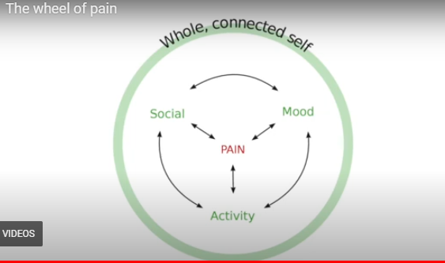

**🌟 Key Learnings**

Pain doesn’t just affect your body—it touches every part of your life.

* It can influence your **mood**, **daily activities**, **social connections**, and **sense of self**.
* These same areas—your mood, activity levels, and relationships—can also influence how you experience pain.
* Pain may cause you and your **whānau** to withdraw or feel isolated.
* By actively managing these areas, you can shape how pain affects you and those around you.

**🛠 Skills to Practise**

* **Connect** with others, including in the online programme—sharing helps reduce isolation.
* **Take notice** of what parts of your life are impacted by pain, and what parts might be impacting your pain.
* **Explore strategies** that help you cope and regain a sense of control.
* Ask yourself: What would it look like to be more ‘in charge’ of your pain experience?

## **❓ Quiz Questions**

## **Question 1:** How can managing your mood, activity, and social interactions influence your pain experience?

## A. It makes pain disappear instantly

## B. It reduces the need for medication

## C. It helps shape how pain affects you and your whānau

## D. It prevents pain from ever returning

## **Explanation:** These areas influence how pain is experienced and how it impacts your life and relationships. **Answer:** C