**Motor Imagery**

Motor imagery (MI) is used alongside physical training. This method is defined as “using all the senses to re-create or create an experience in the mind”. Both motivational and cognitive functions are needed to experience specific skills and to find ways to change the experience.

Motor imagery is valuable for training and rehabilitation, MI is used as a supplementary method for learning functional tasks and sport skills without physical movement or together with them. This technique involves lower costs and no harmful side effects.

In Pain management, Motor Imagery can help you create new movement pathways with less pain. By imagining a movement, how it would feel in all parts of your body, parts of the neural pattern of this movement is activated. Although this can at times triggers pain, this will settle faster than if the movement had been performed physically and on repetition this pain response tends to fade.

By training a movement or activity in this ‘full body immersion’ – visualisation - you can positively change the way you are able to tolerate this activity ‘in real life’.

This is a way we can use our capacity for laying down memory in a helpful way and break cycles where activities always result in pain increases.

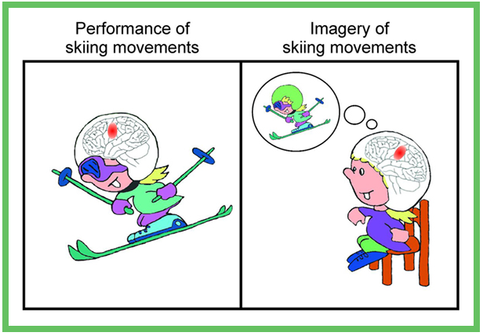

To read more about the science – here are some articles summarising research into this field

<https://pubmed.ncbi.nlm.nih.gov/30222613/>

<https://pmc.ncbi.nlm.nih.gov/articles/PMC10988270/#:~:text=Motor%20imagery%20(MI)%20is%20a,uses%20collateral%20with%20physical%20training.&text=This%20method%20is%20defined%20as,plan%20strategies%20in%20the%20game>.