SKIN CARE GUIDE

Care Workers notify nurses of skin concerns. Nurses notify Doctor or Nurse Prescriber to chart creams.
Avoid soap and water: soap dries skin and alters skin pH, increasing the risk of skin breakdown and infection.
Avoid using excess cream, gently rub in creams, they will ‘shine’ on the skin.
SHOWERING & WASHING | - *Add your product* is a soap substitute for washing and can be used over all skin areas including the buttocks.  - Bed-wash: add cream into a bowl of warm water; agitate to mix. No need to rinse off the skin.  - Showering: wet skin first then apply cream gently rubbing over skin surfaces and rinse. Ensure all skin folds and between toes and hands are cleaned and dried thoroughly.  - Guide: x2 pumps of cream will wash both arms and legs; x1 pump for remaining body areas. |  | Add name/picture of your  soap substitute
SKIN CARE | - Regular skin moisturising reduces the risk of skin tears  - Moisturise skin at least daily to hydrate the skin and reduce the risk of skin damage and skin tears  - Use cream to moisturise arms and legs. Guide: x1 pump to moisturise both arms and x1 pump for the legs.  - Large or moist skin folds: Avoid applying cream to these areas, keep skin folds separated and dry e.g., use low-lint wash cloths. |  | Add name/picture of  your moisturiser
FOOT CARE | - Wash feet and between toes, dry well. Check areas for red skin, callus (thickened skin), blisters or cracks.  - Footwear is clean and dry, free of foreign objects, and not tight to cause red skin marking.  - Ensure bedding and bed end do not apply pressure over toes and feet.  - Residents/Patients with Diabetes are at higher risk for foot complications  - Apply Urea 10% cream to dry skin areas 1-3 times/day (best applied at night when socks and shoes are off).  - Avoid cream between the toes.  - Nurses: Refer to Podiatrist for foot, callus and nail management as per your local policy |  | Add name/picture of your  foot cream
Moisture Related Skin Damage (skin burnt from urine &/or faeces)
Preventative measures – Identify any continence issues, assess and manage and select the most appropriate product if needed.
The nurse must exclude fungal and bacterial infections.
Low-lint wash cloths are soft & gentle to use on damaged skin.
NORMAL OR INFLAMMED WITH NO SKIN BREAKS | 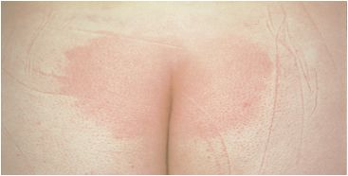 | - Use a soap substitute for washing skin after incontinence.  - *Add your product* = Barrier for intact skin only. Protects skin from urine and faeces.  - Dispense onto the back of your clean glove and apply a thin layer over buttocks and inner thighs. | Add names/pictures of your soap substitute  and barrier product
INFLAMMED WITH SOME SKIN BREAKS |  | - Use a soap substitute for washing skin after incontinence and to remove soiled Zinc cream.  - Apply barrier cream thinly to intact skin areas to protect from urine and faeces.  - For broken skin dispense a pea-size amount of Zinc onto the back of your clean glove, gently ‘pat’ a thin layer onto broken skin areas. | Add names/pictures of your soap substitute, barrier product and zinc cream
INFLAMMED WITH LARGE AREAS OF SKIN BREAKS |  | - Use cream for washing skin after incontinence & to remove soiled Zinc cream.  - Dispense a pea-size amount of Zinc onto the back of your clean glove, gently ‘pat’ a thin layer onto broken skin areas.  - Nurses: if a large skin area is affected Zinc cream can be rubbed into cuticerin and placed over the affected area. | Add names/pictures of your soap substitute, barrier product and zinc cream
FUNGAL INFECTION | 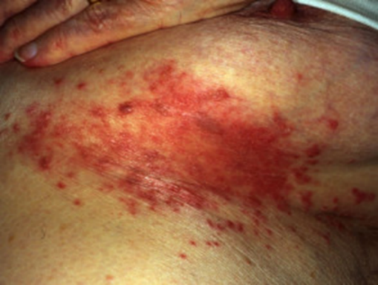 | - Commonly affects under the breasts, skin folds on the stomach or thighs, the armpits and groin.  - Report to the nurse if you see red, pimple-like bumps, odour, itching and burning.  - Keep skin folds clean and dry, use soap substitute, separate skin folds with low lint dry wash cloth and apply prescribed treatment. | Add name/picture of your soap substitute
STOP REGIME if any deterioration: urgent assessment required by Nurse, NP, or GP
Aged Residential Care: Pressure Injury Project Working Group Care Worker Training Module. Published November 2025. HE4342.Available via HealthEd.

